**OOJ LAB REPORT**

**Anirudha Acharya**

**1BM19CS193**

**3-D**

**Semester: 3**

**2020-21**

LAB 1

|  |
| --- |
| Importjava.util.Scanner; |
|  | class Main |
|  |  |
|  | { |
|  | public static void main(String[] args) |
|  | { |
|  | Scanner m = new Scanner(System.in); |
|  | System.out.print ( "Enter a,b,c of the equation:"); |
|  | double a=m.nextDouble(); |
|  | double b=m.nextDouble(); |
|  | double c=m.nextDouble(); |
|  | double d=((b*b)-(4*a*c)); |
|  | double root1 , root2 ; |
|  | if (d>=0) |
|  | { |
|  | root1= (-b - Math.sqrt(d))/(2*a); |
|  | root2= (-b + Math.sqrt(d))/(2*a); |
|  | System.out.println ("Two real roots are:"+root1+" "+root2); |
|  | } |
|  | else |
|  | { |
|  | System.out.println ("No real roots"); |
|  | } |
|  | } |
|  | } |

LAB 2

|  |
| --- |
| importjava.util.Scanner; |
|  | class Student |
|  | { |
|  | String name; |
|  | String usn; |
|  | int marks[] = new int[5]; |
|  | int credits[] = new int[5]; |
|  | int i,n; |
|  | int grade=0; |
|  | double total=0; |
|  |  |
|  | void get_data() |
|  | { |
|  | Scanner in = new Scanner(System.in); |
|  | System.out.println("Enter Student Name:"); |
|  | name = in.next(); |
|  | System.out.println("Enter the USN:"); |
|  | usn = in.next(); |
|  | System.out.println("Enter the no. of subjects:"); |
|  | n=in.nextInt(); |
|  | System.out.println("Enter Subject credits and subject marks:"); |
|  | for(i=0;i<n;i++) |
|  | { |
|  | System.out.println("Credits for subject"+(i+1)+":"); |
|  | credits[i] = in.nextInt(); |
|  | System.out.println("Marks in subject"+(i+1)+":"); |
|  | marks[i] = in.nextInt(); |
|  | } |
|  | } |
|  |  |
|  | void calculate_sgpa() |
|  | { |
|  | for(i=0;i<n;i++) |
|  | { |
|  | if(marks[i]>=90 && marks[i]<=100) |
|  | grade=10; |
|  | else if(marks[i]>=80 && marks[i]<=90) |
|  | grade=9; |
|  | else if(marks[i]>=70 && marks[i]<=80) |
|  | grade=8; |
|  | else if(marks[i]>=60 && marks[i]<=70) |
|  | grade=7; |
|  | else if(marks[i]>=50 && marks[i]<=60) |
|  | grade=6; |
|  | else if(marks[i]>=40 && marks[i]<=50) |
|  | grade=5; |
|  | else if(marks[i]>=0 && marks[i]<=40) |
|  | grade=0; |
|  | else |
|  | System.out.println("Invalid marks entered"); |
|  | total=total+(grade*credits[i]); |
|  | } |
|  |  |
|  | total=total/20; |
|  | System.out.println("Sgpa="+total); |
|  | } |
|  |  |
|  | void stud_details() |
|  | { |
|  | System.out.println("Name:"+name); |
|  | System.out.println("USN:"+usn); |
|  | System.out.println("Marks & Credits of all subjects:"); |
|  | for(i=0;i<n;i++) |
|  | { |
|  | System.out.println("subject:"+(i+1)+":"); |
|  | System.out.println("Marks:"+marks[i]); |
|  | System.out.println("Credits:"+credits[i]); |
|  | } |
|  | calculate_sgpa(); |
|  | } |
|  |  |
|  | public static void main(String args[]) |
|  | { |
|  | Student s = new Student(); |
|  | s.get_data(); |
|  | s.calculate_sgpa(); |
|  | s.stud_details(); |
|  | } |
|  | } |

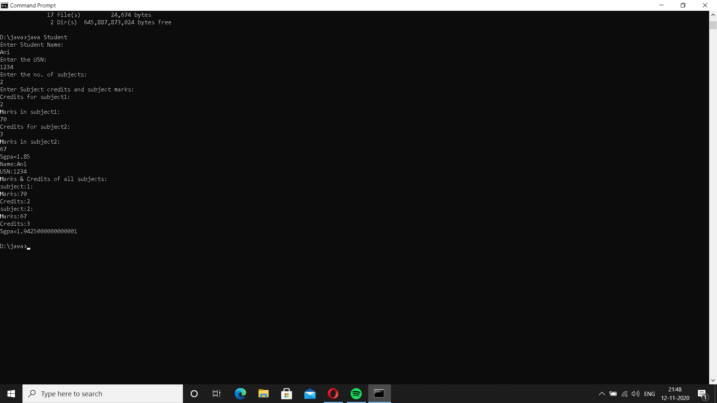

LAB 3

|  |
| --- |
| importjava.util.Scanner; |
|  | class Book |
|  | { |
|  | private String name; |
|  | private String author; |
|  | private double price; |
|  | private int num_pages; |
|  |  |
|  | Book() |
|  | { |
|  | name="xyz"; |
|  | author="abc"; |
|  | price= 0.0; |
|  | num_pages=10; |
|  | } |
|  | void getdata() |
|  | { |
|  | Scanner sc= new Scanner(System.in); |
|  | System.out.println("enter name of book"); |
|  | name = sc.nextLine(); |
|  | System.out.println("enter name of author"); |
|  | author = sc.nextLine(); |
|  | System.out.println("enter price of book"); |
|  | price = sc.nextDouble(); |
|  | System.out.println("enter the number of pages"); |
|  | num_pages = sc.nextInt(); |
|  | } |
|  |  |
|  | public String toString() |
|  | { |
|  | return("Book: "+name+"\nAuthor: "+author+"\nPrice: Rs "+price+"\nNo.of pages: "+num_pages); |
|  | } |
|  | } |
|  | class lab3 |
|  | { |
|  | public static void main(String ss[]) |
|  | { |
|  | Scanner xx=new Scanner(System.in); |
|  | System.out.println("Enter the number of books:"); |
|  | int n=xx.nextInt(); |
|  | Book b[]=new Book[n]; |
|  | int i; |
|  | System.out.println("Enter the book details"); |
|  | for(i=0;i<n;i++) |
|  | { |
|  | System.out.println("Book "+(i+1)); |
|  | b[i]=new Book(); |
|  | b[i].getdata(); |
|  | } |
|  | System.out.println("Printing book details...."); |
|  | for(i=0;i<n;i++) |
|  | { |
|  | System.out.println("Book "+(i+1)); |
|  | System.out.println(b[i]); |
|  | System.out.println("-------------"); |
|  |  |
|  | } |
|  | } |
|  | } |

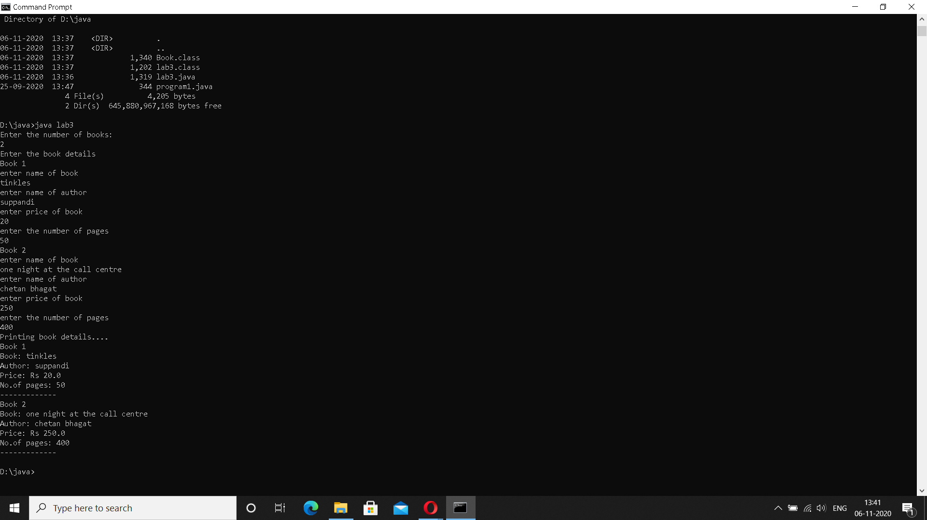

LAB 4

|  |
| --- |
| import java.util.Scanner; |
|  | abstract class Shape |
|  | { |
|  | int a; |
|  | int b; |
|  |  |
|  | abstract void printArea(); |
|  | } |
|  | class Rectangle extends Shape |
|  | { |
|  | Rectangle(int x, int y) |
|  | { |
|  | a=x; |
|  | b=y; |
|  | } |
|  |  |
|  | void printArea() |
|  | { |
|  | System.out.println("Area is "+(a*b)); |
|  | } |
|  | } |
|  |  |
|  | class Triangle extends Shape |
|  | { |
|  | Triangle(int x, int y) |
|  | { |
|  | a=x; |
|  | b=y; |
|  | } |
|  | void printArea() |
|  | { |
|  | System.out.println("Area is "+(a*b*0.5)); |
|  | } |
|  | } |
|  | class Circle extends Shape |
|  | { |
|  | Circle(int x) |
|  | { |
|  | a=x; |
|  | } |
|  | void printArea() |
|  | { |
|  | System.out.println("Area is "+(a*a*3.14)); |
|  | } |
|  | } |
|  |  |
|  | class lab4 |
|  | { |
|  | public static void main(String ss[]) |
|  | { |
|  | int l,b,ba,h,ra; |
|  | Scanner sc = new Scanner(System.in); |
|  |  |
|  | System.out.println("enter the length and breadth of rectangle"); |
|  | l= sc.nextInt(); |
|  | b= sc.nextInt(); |
|  | Rectangle r= new Rectangle(l,b); |
|  | r.printArea(); |
|  |  |
|  | System.out.println("enter the base and height of triangle"); |
|  | ba= sc.nextInt(); |
|  | h= sc.nextInt(); |
|  | Triangle t = new Triangle(ba,h); |
|  | t.printArea(); |
|  |  |
|  | System.out.println("enter the radius of circle"); |
|  | ra= sc.nextInt(); |
|  | Circle c = new Circle(ra); |
|  | c.printArea(); |
|  | } |
|  | } |
|  |  |

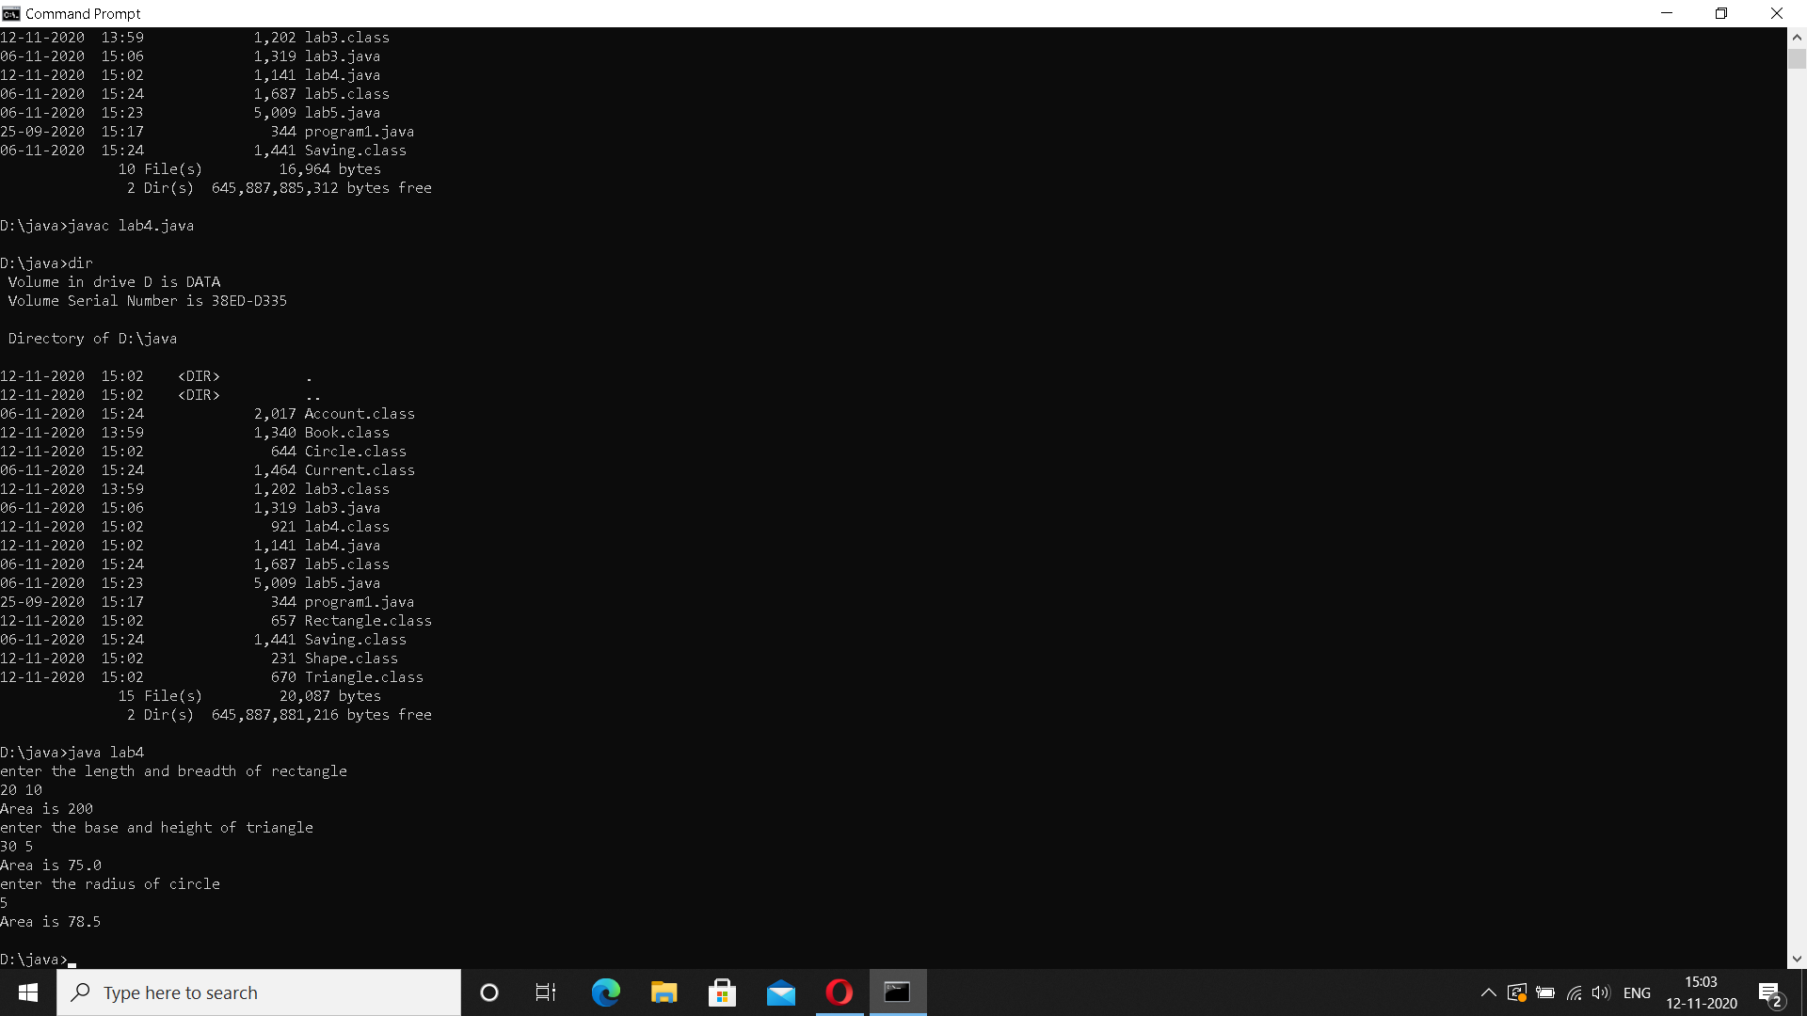

LAB 5

|  |
| --- |
| import java.util.Scanner; |
|  | import java.lang.Math; |
|  | class Account |
|  | { |
|  | String name; |
|  | int acctno; |
|  | char type; |
|  | double balance; |
|  | double dep; |
|  | boolean cheq; |
|  |  |
|  | void get(char c) |
|  | { |
|  | type = c; |
|  | if(c=='s' || c == 'S') |
|  | cheq=false; |
|  | else cheq=true; |
|  | Scanner sc = new Scanner(System.in); |
|  | System.out.println("Enter your name"); |
|  | name = sc.nextLine(); |
|  | System.out.println("Enter the account number"); |
|  | acctno = sc.nextInt(); |
|  | System.out.println("Enter the current available balance in your account"); |
|  | balance= sc.nextDouble(); |
|  | } |
|  |  |
|  | void putd() |
|  | { |
|  | System.out.println("Account details"); |
|  | System.out.println("Name: "+name); |
|  | System.out.println("Account number: "+acctno); |
|  | System.out.println("Account type :"+type); |
|  | System.out.println("balance: "+balance); |
|  | } |
|  | void dep() |
|  | { |
|  | Scanner ss = new Scanner(System.in); |
|  | System.out.println("Enter amount to be deposited"); |
|  | dep= ss.nextDouble(); |
|  | balance=balance +dep; |
|  | System.out.println("Amount is deposited and balance is updated"); |
|  | } |
|  | void display() |
|  | { |
|  |  |
|  | System.out.println("Balance amount is "+balance); |
|  | } |
|  |  |
|  | void check() |
|  | { |
|  | if(cheq==false) |
|  | System.out.println("Cheque book facility is not available"); |
|  | else |
|  | System.out.println("Cheque book facility is available"); |
|  |  |
|  | } |
|  |  |
|  |  |
|  | } |
|  |  |
|  | class Saving extends Account |
|  | { |
|  |  |
|  | double rate; |
|  |  |
|  | double s_with; |
|  | int n; |
|  |  |
|  | int ch; |
|  | double amt; |
|  | double term; |
|  | double pr; |
|  |  |
|  |  |
|  |  |
|  | void ci() |
|  | { |
|  | Scanner ss = new Scanner(System.in); |
|  | System.out.println("Enter the principal deposit amount"); |
|  | pr = ss.nextDouble(); |
|  | System.out.println("Enter rate of interest"); |
|  | rate = ss.nextDouble(); |
|  | System.out.println("Enter the term(years)"); |
|  | term = ss.nextDouble(); |
|  | System.out.println("Enter the number of times interest in compounded annually"); |
|  | n = ss.nextInt(); |
|  | amt = pr* Math.pow((1+(rate/100)),(n*term)); |
|  | balance+= amt; |
|  | System.out.println("Interest is compounded and deposited; balance is updated"); |
|  |  |
|  | } |
|  |  |
|  | void with_s() |
|  | { |
|  |  |
|  | Scanner ss = new Scanner(System.in); |
|  | System.out.println("Enter the amount of money to be withdrawn"); |
|  | s_with = ss.nextDouble(); |
|  | if(s_with>balance) |
|  | System.out.println("Insufficient balance"); |
|  | else |
|  | {balance= balance - s_with; |
|  | System.out.println("Money is withdrawn and balance is updated");} |
|  | } |
|  |  |
|  |  |
|  |  |
|  |  |
|  |  |
|  | } |
|  |  |
|  | class Current extends Account |
|  | { |
|  |  |
|  | double c_with; |
|  | double pen; |
|  | double min; |
|  | Current() |
|  | { |
|  | pen=100; |
|  | min=500; |
|  | } |
|  |  |
|  | void with_c() |
|  | { |
|  | Scanner xx = new Scanner(System.in); |
|  | System.out.println("Enter the amount to be withdrawn"); |
|  | c_with= xx.nextDouble(); |
|  | if(c_with>balance) |
|  | {System.out.println("Insufficient funds!"); |
|  | return;} |
|  | else |
|  | {balance= balance- c_with; |
|  | System.out.println("Amount is withdrawn and balance is updated");} |
|  | if(balance<min) |
|  | { |
|  | System.out.println("Balance is below the minimum threshold. Service penalty charge = 100/- ."); |
|  | if(balance<pen) |
|  | System.out.println("Due to insufficient funds, penalty charge will be deducted from account after replenishing. Current balance is "+balance); |
|  | else |
|  | { |
|  | balance= balance-pen; |
|  | System.out.println("Penalty charge has been deducted from account balance. Current balance is "+balance); |
|  | } |
|  | } |
|  | } |
|  |  |
|  |  |
|  | } |
|  |  |
|  | class lab5 |
|  | { |
|  | public static void main(String sss[]) |
|  | { |
|  | int cch, chh; |
|  | Scanner sx = new Scanner(System.in); |
|  | System.out.println("Welcome"); |
|  | System.out.println("Savings account or current account? 1- Savings; 2- Current"); |
|  | int ch= sx.nextInt(); |
|  | if(ch==1) |
|  | { |
|  | Saving s = new Saving(); |
|  | s.get('S'); |
|  | do{ |
|  | System.out.println("1. Deposit money\n2. Calculate compound interest\n3. Withdraw money\n4. Display balance\n5. Cheque book facility\n6. Exit"); |
|  | System.out.println("Enter your choice"); |
|  | chh= sx.nextInt(); |
|  | switch(chh) |
|  | { |
|  | case 1: |
|  | s.dep(); |
|  | break; |
|  |  |
|  | case 2: |
|  | s.ci(); |
|  | break; |
|  |  |
|  | case 3: |
|  | s.with_s(); |
|  | break; |
|  |  |
|  | case 4: |
|  | s.display(); |
|  | break; |
|  |  |
|  | case 5: |
|  | s.check(); |
|  | break; |
|  |  |
|  | case 6: |
|  | break; |
|  |  |
|  | default: |
|  | System.out.println("Wrong option."); |
|  | break; |
|  | } |
|  | }while(chh!=6); |
|  |  |
|  | } |
|  | else if(ch==2) |
|  | { |
|  | Current cr = new Current(); |
|  | cr.get('C'); |
|  | do{ |
|  | System.out.println("1. Deposit money\n2. Chequebook facility\n3. Withdraw money\n4. Display balance\n5. Exit"); |
|  | cch= sx.nextInt(); |
|  | switch(cch) |
|  | { |
|  | case 1: |
|  | cr.dep(); |
|  | break; |
|  |  |
|  | case 2: |
|  | cr.check(); |
|  | break; |
|  |  |
|  | case 3: |
|  | cr.with_c(); |
|  | break; |
|  |  |
|  | case 4: |
|  | cr.display(); |
|  | break; |
|  |  |
|  | case 5: |
|  | break; |
|  |  |
|  | default: |
|  | System.out.println("Wrong option."); |
|  | break; |
|  | } |
|  | }while(cch!=5); |
|  |  |
|  |  |
|  |  |
|  | } |
|  | else System.out.println("Wrong!"); |
|  | } |
|  | } |

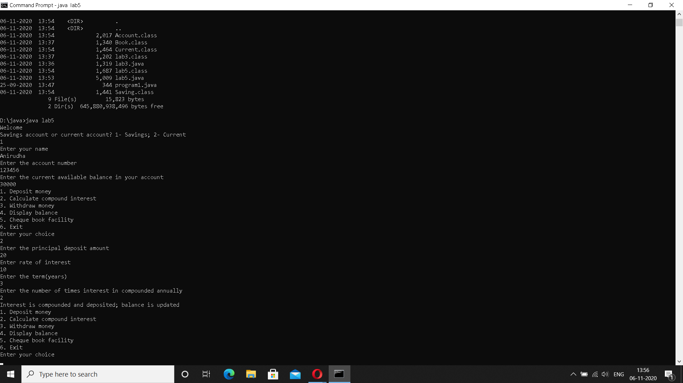

LAB 6

|  |
| --- |
| **MAIN**  import CIE.*; |
|  | import SEE.*; |
|  | import java.util.Scanner; |
|  |  |
|  | class Main |
|  | { |
|  | public static void main(String args[]) |
|  | { |
|  | Scanner sx = new Scanner(System.in); |
|  | System.out.println("Enter the number of students"); |
|  | int n= sx.nextInt(); |
|  | CIE.internals in[]= new CIE.internals[n]; |
|  | SEE.externals en[]= new SEE.externals[n]; |
|  | int i,j; |
|  | for(i=0;i<n;i++) |
|  | { |
|  | System.out.println("Student "+(i+1)); |
|  | in[i] = new CIE.internals(); |
|  | en[i] = new SEE.externals(); |
|  | in[i].read(); |
|  |  |
|  | System.out.println("CIE MARKS:"); |
|  | in[i].accept(); |
|  | System.out.println("SEE MARKS:"); |
|  | en[i].get(); |
|  | System.out.println(); |
|  | in[i].display(); |
|  | for(j=0;j<5;j++) |
|  |  |
|  | System.out.println("Total Marks for course "+(j+1)+": "+(in[i].cie[j] + (en[i].see[j]/2))); |
|  | } |
|  | } |
|  | } |

**PERSONAL**

|  |
| --- |
| package CIE; |
|  | import java.util.Scanner; |
|  | public class personal |
|  | { |
|  | public String name; |
|  | public int sem; |
|  | public String usn; |
|  |  |
|  | public void read() |
|  | { |
|  | Scanner sc = new Scanner(System.in); |
|  | System.out.println("Enter the name"); |
|  | name = sc.next(); |
|  | System.out.println("Enter the semester"); |
|  | sem = sc.nextInt(); |
|  | System.out.println("Enter the USN"); |
|  | usn = sc.next(); |
|  | } |
|  | public void display() |
|  | { |
|  | System.out.println("Student details: "); |
|  | System.out.println("Name: "+name+"\nUSN: "+usn+"\nSem: "+sem); |
|  | } |
|  |  |
|  |  |
|  | } |

**EXTERNALS**

|  |
| --- |
| package SEE; |
|  | import java.util.Scanner; |
|  | import CIE.*; |
|  |  |
|  | public class externals extends personal |
|  | { |
|  | public double see[]; |
|  |  |
|  | public void get() |
|  | { |
|  | see= new double[5]; |
|  | Scanner sc = new Scanner(System.in); |
|  | for(int i=0;i<5;i++) |
|  | { |
|  | System.out.println("SEE mark for course "+(i+1)+" : "); |
|  | see[i]= sc.nextDouble(); |
|  | } |
|  | } |
|  |  |
|  |  |
|  | } |

**INTERNALS**

|  |
| --- |
| package CIE; |
|  | import java.util.Scanner; |
|  | public class internals extends personal |
|  | { |
|  | public double cie[]; |
|  |  |
|  | public void accept() |
|  | { |
|  | cie= new double[5]; |
|  | Scanner sc = new Scanner(System.in); |
|  | for(int i=0;i<5;i++) |
|  | { |
|  | System.out.println("CIE mark for course "+(i+1)+" : "); |
|  | cie[i]= sc.nextDouble(); |
|  | } |
|  | } |
|  |  |
|  |  |
|  |  |
|  | } |

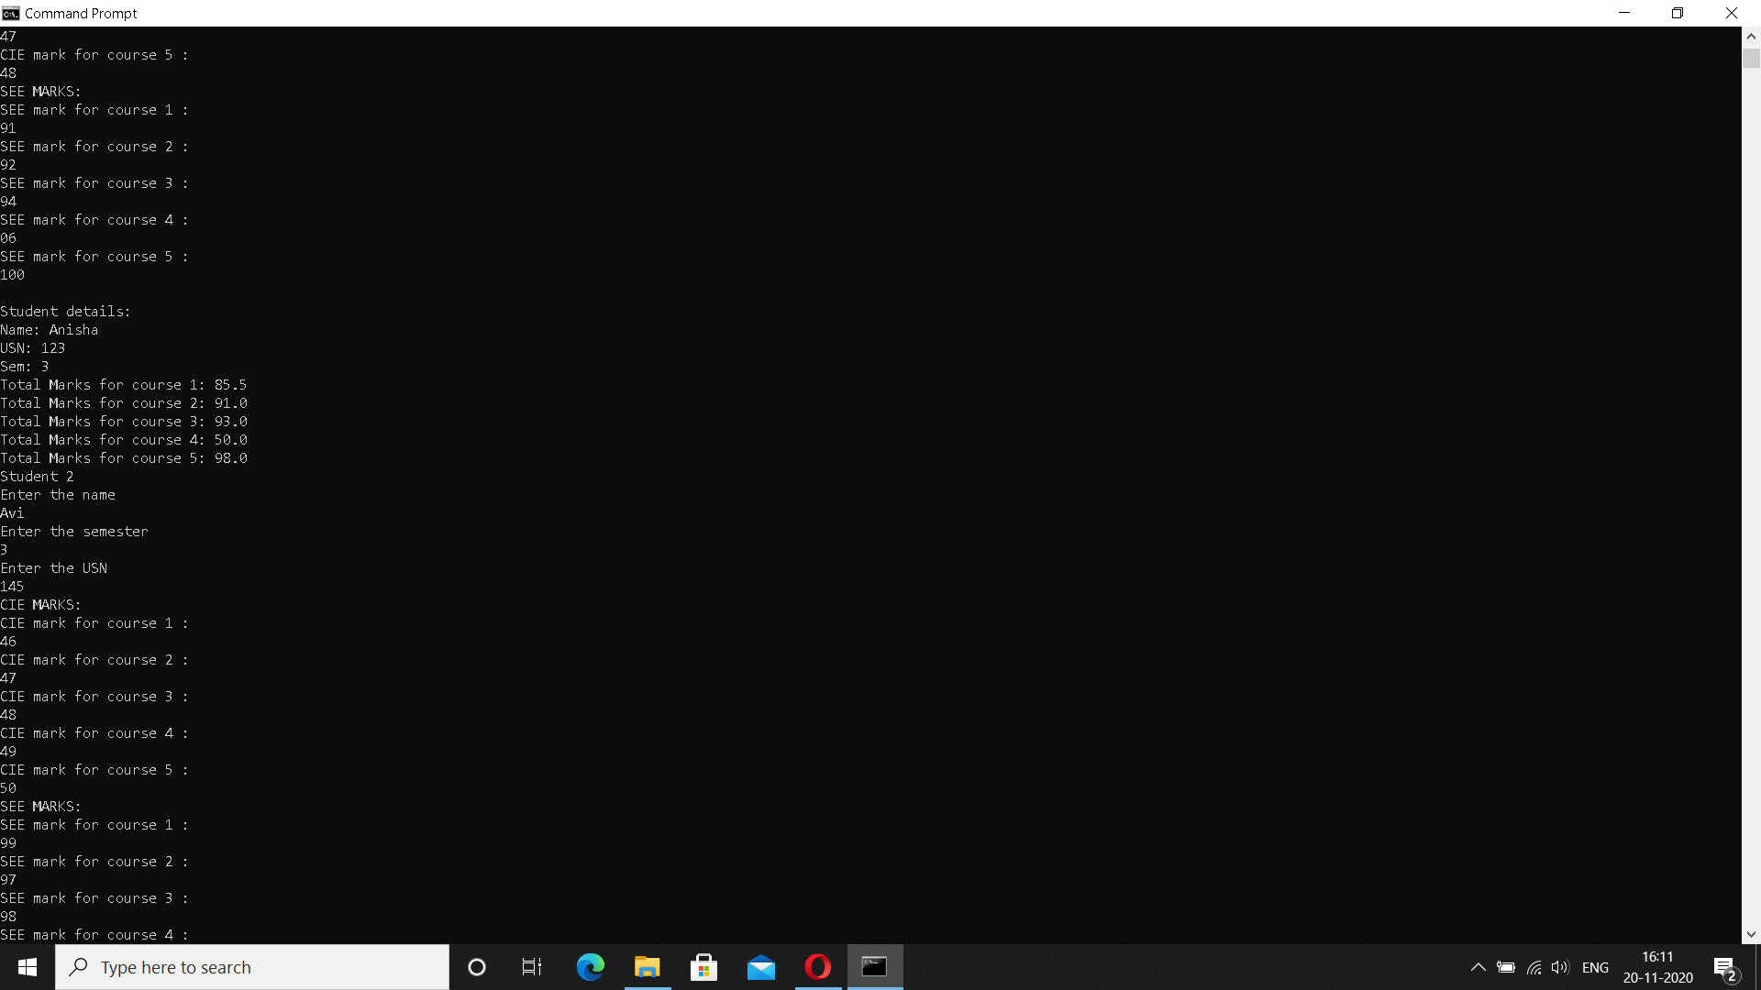

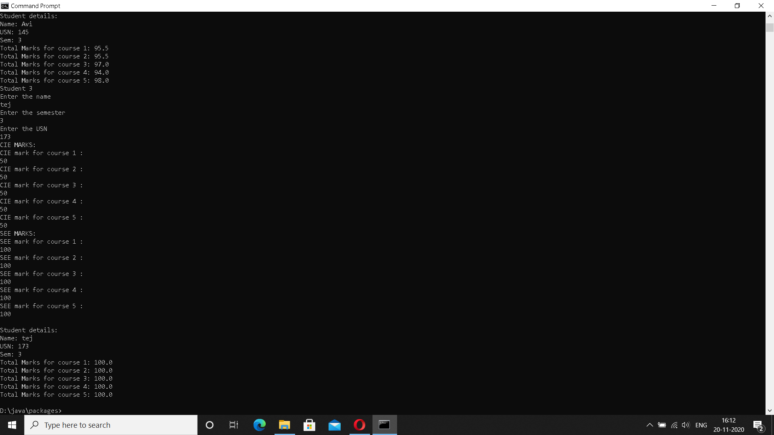

LAB 7

|  |
| --- |
| class TwoGen<T, V> |
|  | { |
|  | T ob1; |
|  | V ob2; |
|  | TwoGen(T o1, V o2) |
|  | { |
|  | ob1 = o1; |
|  | ob2 = o2; |
|  | } |
|  | void showTypes() { |
|  | System.out.println("Type of T is " +ob1.getClass().getName()); |
|  | System.out.println("Type of V is " +ob2.getClass().getName()); |
|  | } |
|  | T getob1() { |
|  | return ob1; |
|  | } |
|  | V getob2() { |
|  | return ob2; |
|  | } |
|  | } |
|  | class SimpGen { |
|  | public static void main(String args[]) |
|  | { |
|  | TwoGen<Integer, String> tgObj = new TwoGen<Integer, String>(88, "Generics"); |
|  | tgObj.showTypes(); |
|  | int v = tgObj.getob1(); |
|  | System.out.println("value: " + v); |
|  | String str = tgObj.getob2(); |
|  | System.out.println("value: " + str); |
|  | } |
|  | } |

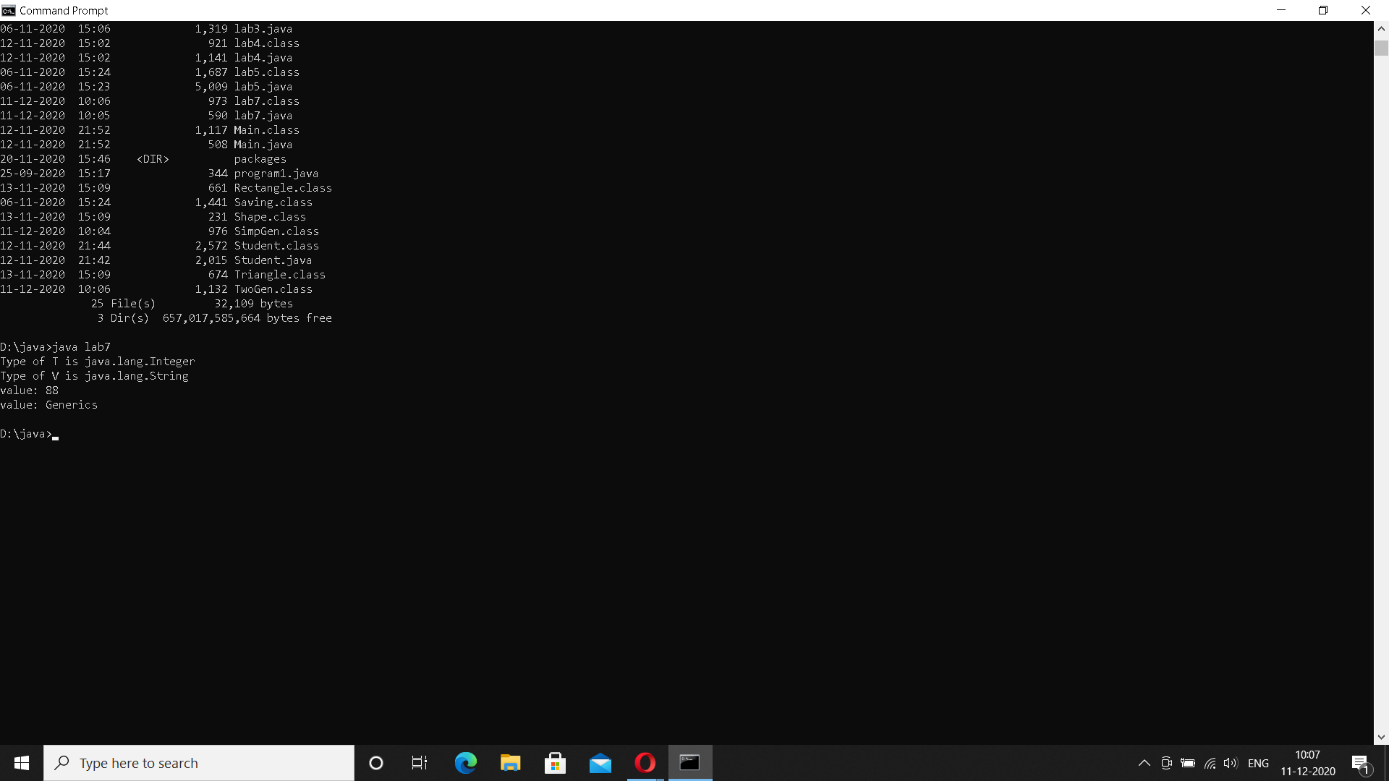

LAB 8

|  |
| --- |
| import java.util.*; |
|  | class WrongAge extends Exception |
|  | { |
|  | private int a1,b1; |
|  | WrongAge(int a,int b) |
|  | { |
|  | a1=a; |
|  | b1=b; |
|  | } |
|  | public String toString() |
|  | { |
|  | if(a1<0||b1<0) |
|  | return "input age cannot be less than 0"; |
|  | else if(a1<=b1) |
|  | return "father's age cannot be less than or equal to son's age "; |
|  | return ""; |
|  | } |
|  | } |
|  |  |
|  | class Father |
|  | { |
|  | int fage,sage; |
|  | Scanner sc=new Scanner(System.in); |
|  | Father() throws WrongAge |
|  | { |
|  | System.out.println("enter age of father"); |
|  | fage=sc.nextInt(); |
|  | System.out.println("enter age of son"); |
|  | sage=sc.nextInt(); |
|  | if(fage<0||sage<0) |
|  | throw new WrongAge(fage,sage); |
|  |  |
|  |  |
|  |  |
|  | } |
|  | } |
|  |  |
|  | class Son extends Father |
|  | { |
|  |  |
|  | Son() throws WrongAge |
|  | { |
|  |  |
|  | if(sage>=fage) |
|  | throw new WrongAge(fage,sage); |
|  | else |
|  | System.out.println("proper ages have been entered"); |
|  | } |
|  | } |
|  |  |
|  | class lab8 |
|  | { |
|  | public static void main(String args[]) |
|  | { |
|  |  |
|  | try |
|  | { |
|  | Son s=new Son(); |
|  | }catch(WrongAge e){ |
|  | System.out.println("error:"+e); |
|  |  |
|  | } |
|  | } |
|  | } |

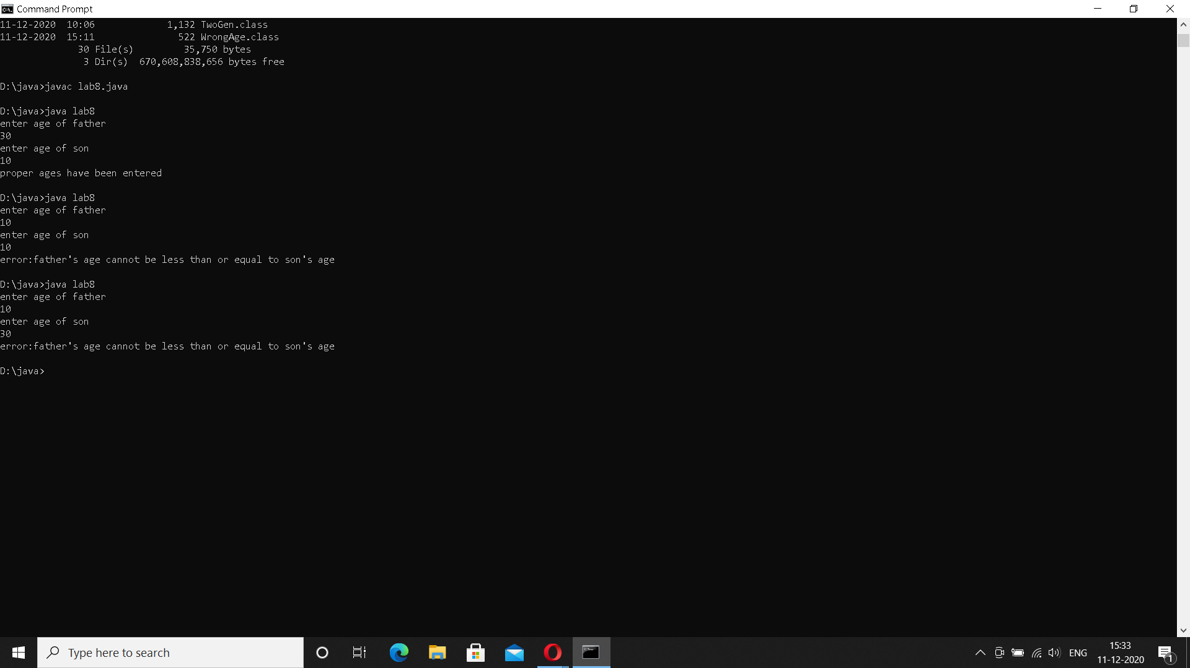

LAB 9

|  |
| --- |
| import java.util.*; |
|  | import java.lang.*; |
|  |  |
|  | class NewThread implements Runnable { |
|  | String name; |
|  | int interval; |
|  | int repeat; |
|  | Thread t; |
|  | NewThread(String name,int interval,int repeat){ |
|  | this.name = name; |
|  | this.repeat = repeat; |
|  | this.interval = interval; |
|  | t = new Thread(this,name); |
|  | t.start(); |
|  | } |
|  | public void run(){ |
|  | try{ |
|  | for(int i=repeat;i>0;i--){ |
|  | System.out.println(""+name); |
|  | Thread.sleep(interval); |
|  | } |
|  | }catch(InterruptedException e){ |
|  | System.out.println("Child Interrupted "+name); |
|  | } |
|  | } |
|  | } |
|  |  |
|  | class lab9 { |
|  | public static void main(String args[]){ |
|  | new NewThread("BMS College of Engineering",10000,5); |
|  | new NewThread("CSE",2000,20); |
|  | try{ |
|  | for(int i=5;i>0;i--){ |
|  | Thread.sleep(10000); |
|  | } |
|  | } |
|  | catch(InterruptedException e){ |
|  | System.out.println("Main Thread Interrupted"); |
|  | } |
|  | } |
|  | } |

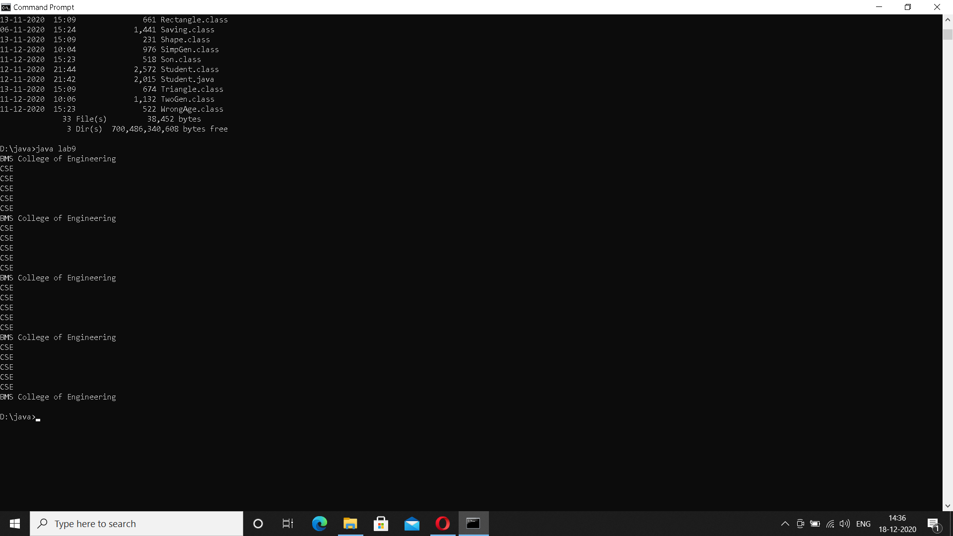

LAB 10

|  |
| --- |
| import java.awt.*; |
|  | import java.awt.event.*; |
|  |  |
|  | class SampleDialog extends Dialog implements ActionListener { |
|  | lab10 bld; |
|  | SampleDialog(Frame parent, String title) { |
|  |  |
|  | super(parent, title, false); |
|  | bld=(lab10)parent; |
|  | setLayout(new FlowLayout()); |
|  | setSize(300, 200); |
|  | add(new Label(bld.msg1)); |
|  | Button b; |
|  | add(b = new Button("OK")); |
|  | b.addActionListener(this); |
|  | } |
|  | public void actionPerformed(ActionEvent ae) { |
|  | dispose(); |
|  | } |
|  |  |
|  | } |
|  |  |
|  | public class lab10 extends Frame implements ActionListener |
|  | { |
|  | TextField num1,num2,result; |
|  |  |
|  | String msg="",msg1=""; |
|  | Button divide; |
|  | public lab10() |
|  | { |
|  | setLayout(new FlowLayout()); |
|  | Label nnum1=new Label("Num1: ",Label.RIGHT); |
|  | Label nnum2=new Label("Num2: ",Label.RIGHT); |
|  | Label rresult=new Label("Result: ",Label.RIGHT); |
|  | Button b=new Button("divide"); |
|  |  |
|  | num1=new TextField(8); |
|  | num2=new TextField(8); |
|  | result=new TextField(8); |
|  |  |
|  |  |
|  | add(nnum1); |
|  | add(num1); |
|  | add(nnum2); |
|  | add(num2); |
|  | divide=(Button)add(b); |
|  | add(rresult); |
|  | add(result); |
|  |  |
|  |  |
|  | num1.addActionListener(this); |
|  | num2.addActionListener(this); |
|  | divide.addActionListener(this); |
|  |  |
|  | addWindowListener(new WindowAdapter() |
|  | { |
|  | public void windowClosing(WindowEvent we) |
|  | { |
|  | System.exit(0); |
|  | } |
|  | }); |
|  | } |
|  | public void actionPerformed(ActionEvent ae) |
|  | { |
|  | if(ae.getSource()==divide) |
|  | { |
|  | try |
|  | { |
|  | msg=""+Integer.parseInt(num1.getText())/Integer.parseInt(num2.getText()); |
|  | String c=""+msg; |
|  | result.setText(c); |
|  | msg1=""; |
|  |  |
|  | }catch(NumberFormatException e) |
|  | { |
|  | msg1="Entered number is not an integer "+e; |
|  | SampleDialog d = new SampleDialog(this, "Dialog"); |
|  | d.setVisible(true); |
|  |  |
|  | } |
|  | catch(ArithmeticException e) |
|  | { |
|  | msg1="number 2 is zero "+e; |
|  | SampleDialog d = new SampleDialog(this, "Dialog"); |
|  | d.setVisible(true); |
|  |  |
|  | } |
|  | } |
|  | } |
|  |  |
|  | public static void main(String[] args) |
|  | { |
|  | lab10 aa=new lab10(); |
|  | aa.setSize(new Dimension(400,200)); |
|  | aa.setTitle("divide_awt"); |
|  | aa.setVisible(true); |
|  | } |
|  |  |
|  | } |

